**Custom image creation - VM agent, puppet agent installation and then generalize image and capture**

**Puppet Installation [Master server]**

***Puppet:*** Configuration management tool that is used for deploying, configuring and managing servers

Step1: Create puppet enterprise server 2017.2

s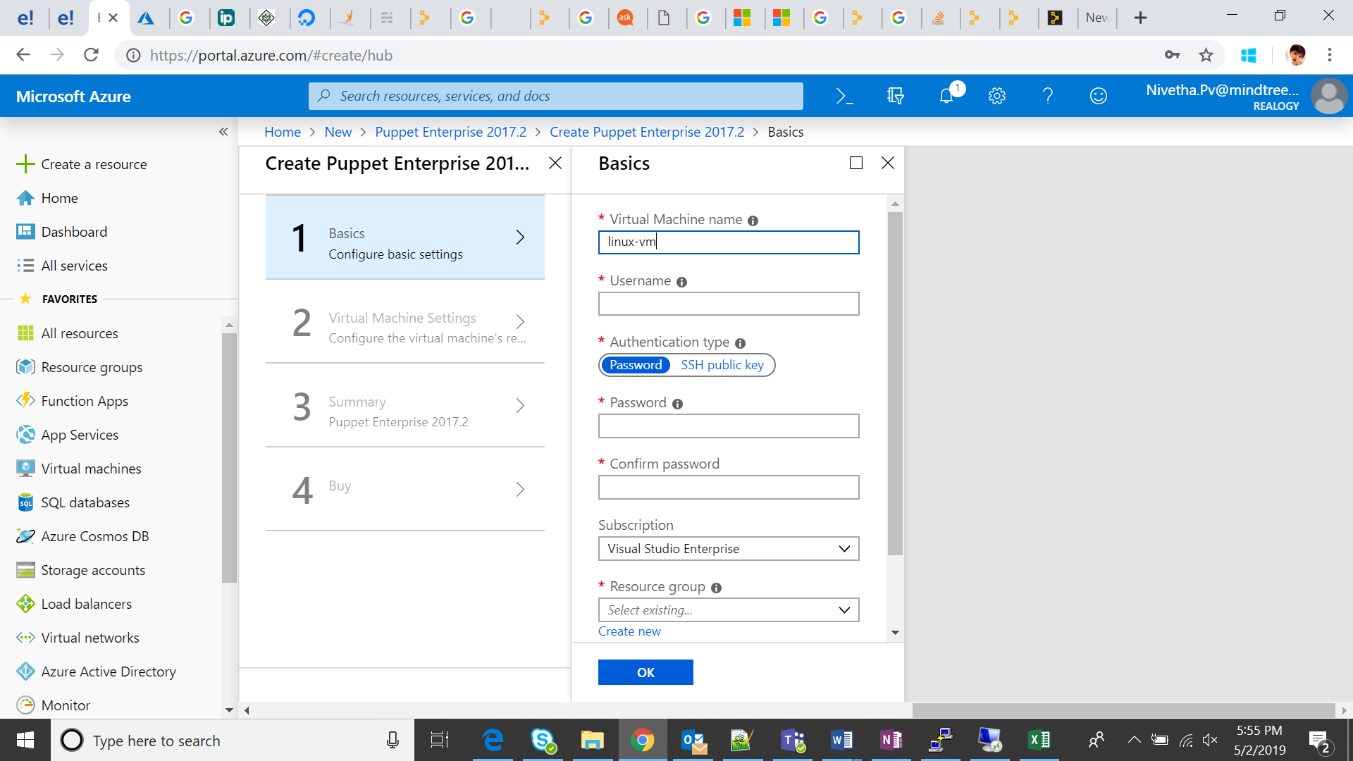

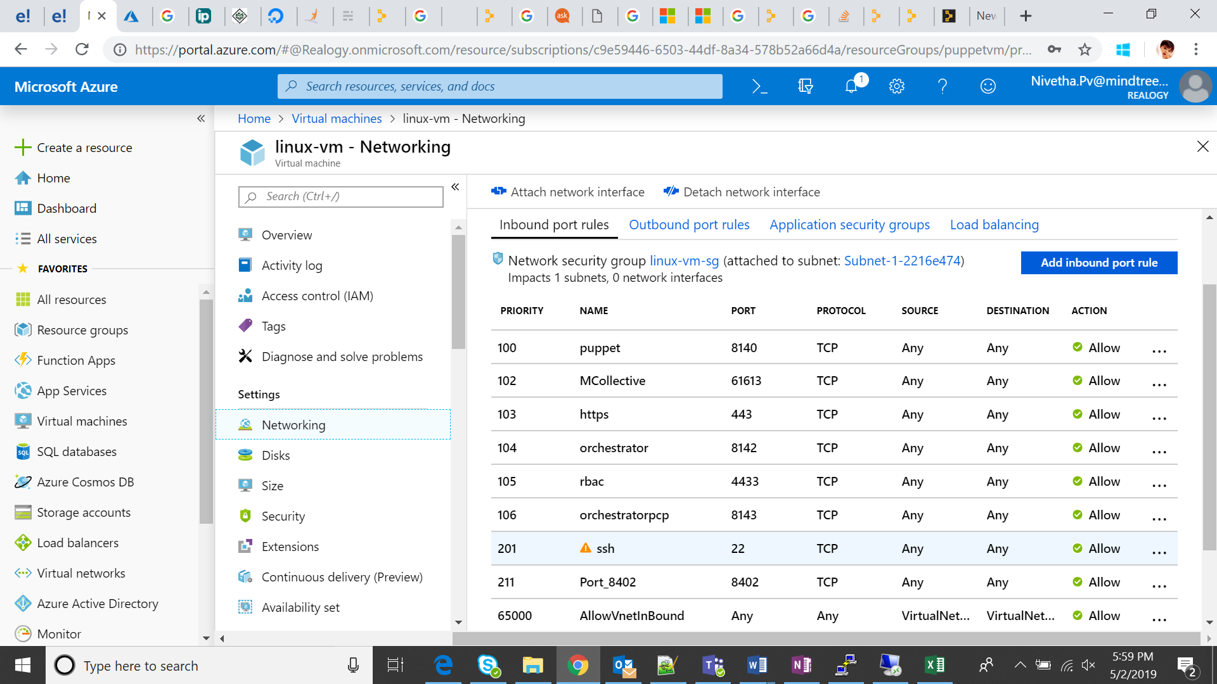

Note: Minimum capacity – 2VCore, 1 GB memory with DNS name configured

Step2: Connect to the puppet server and check the status of the services using the following commands

systemctl status pe-puppetserver  
systemctl status pe-console-services

If the service in sleep mode, start the services by using the following commands

systemctl start pe-puppetserver  
systemctl start pe-console-services

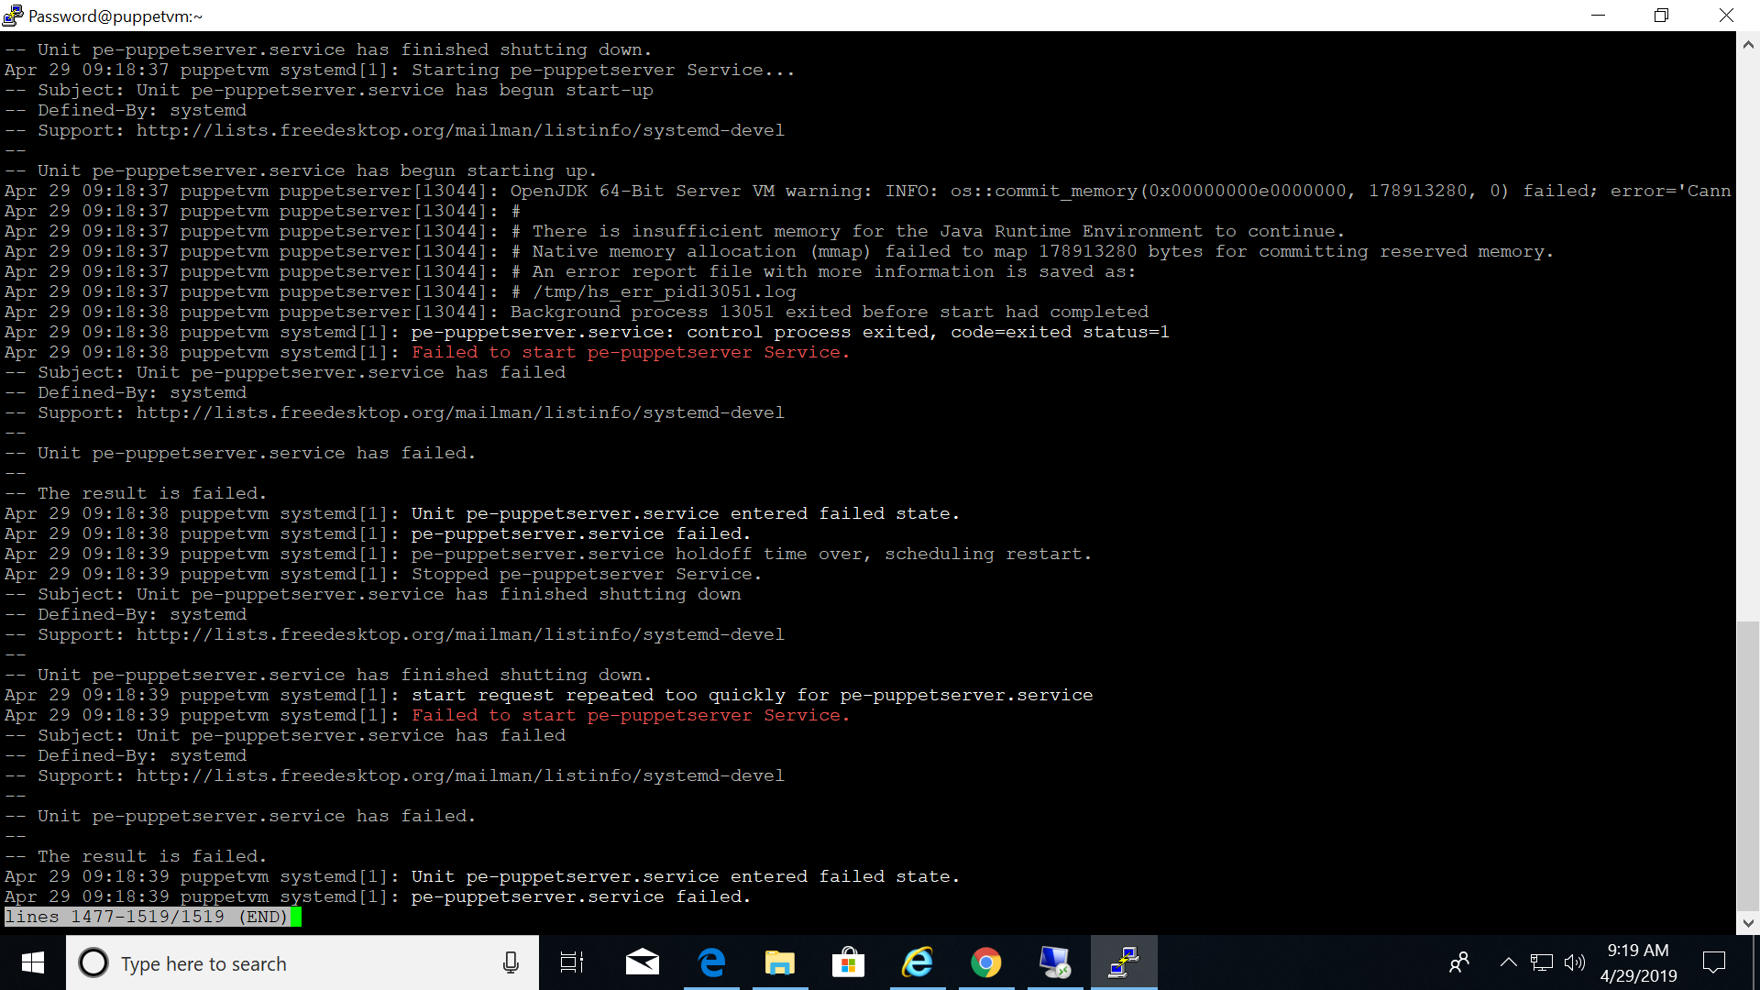

Step3: Run the below command to set the password for puppet console

sudo /opt/puppetlabs/cloud/bin/set_console_password.sh

Step4: Navigate to the puppet console with its dns name (Example: [https://linux-vm-40c8e98a.eastus.cloudapp.azure.com](https://linux-vm-40c8e98a.eastus.cloudapp.azure.com/)) and login with default user name (admin) and password set in step 3.

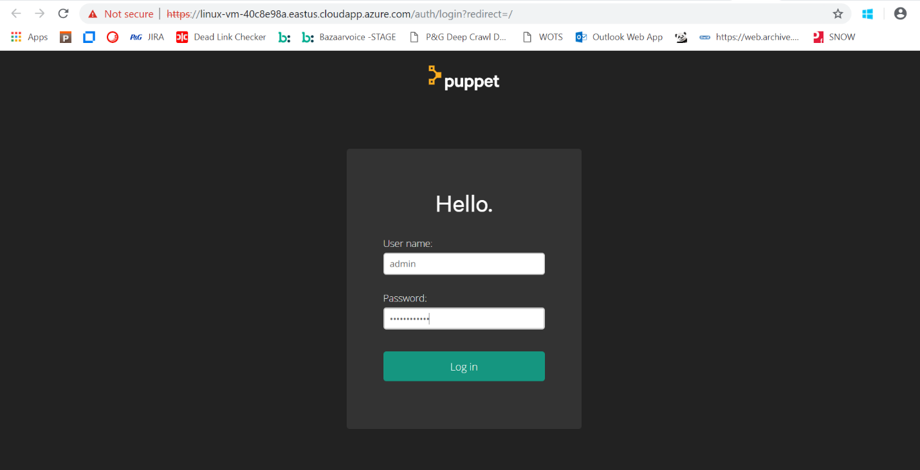

**Puppet Extension [Client server]**

Add the puppet agent to the client vm as an extension as below

Step1: Go to VM -> Extension -> Add Extensions -> Puppet agent -> Create

Give the DNS name in the Puppet master server tab

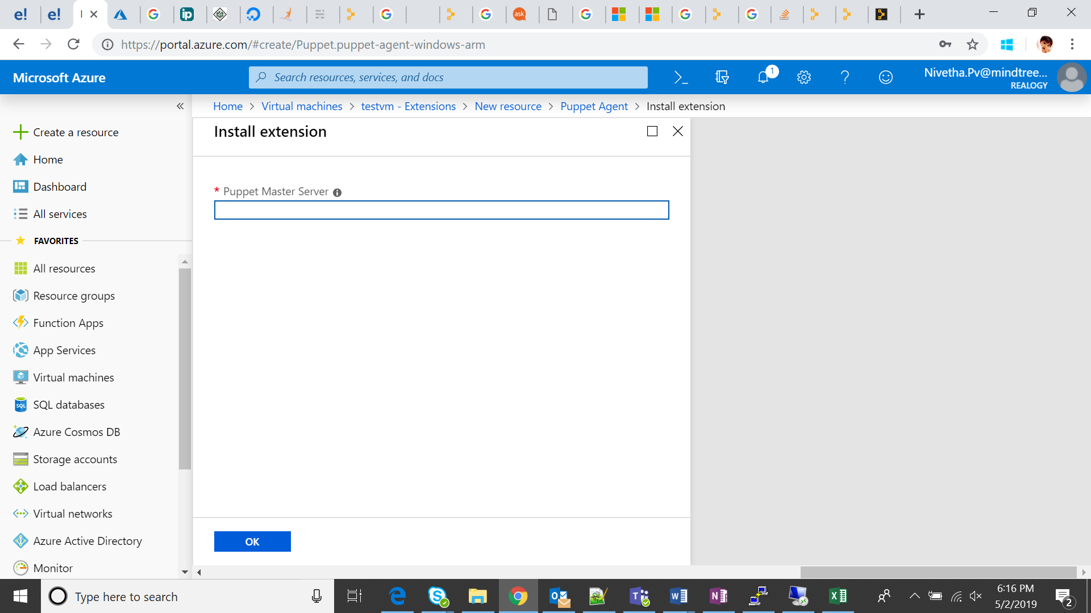

Step2: Open the puppet console and accept the certificates

Go to Unsigned certs -> Accept

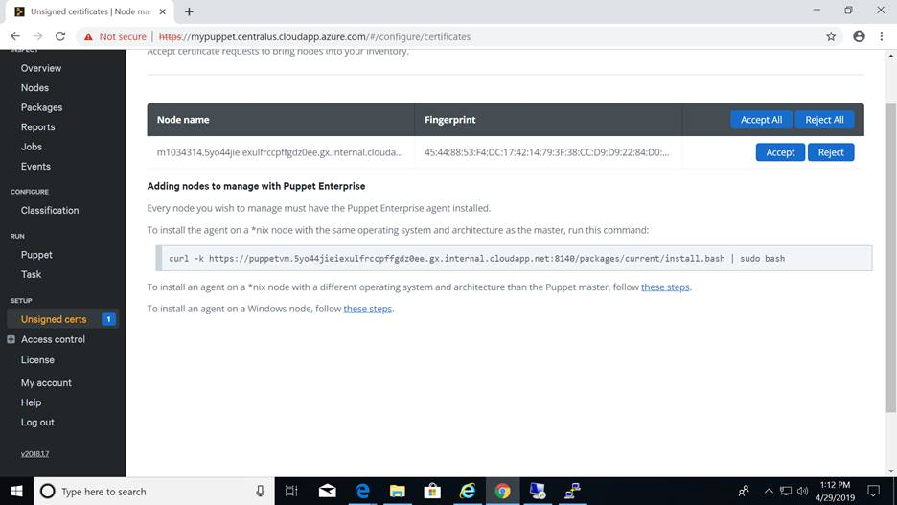

Step3: Connect to the VM and go to start and search for “Run Puppet Agent”

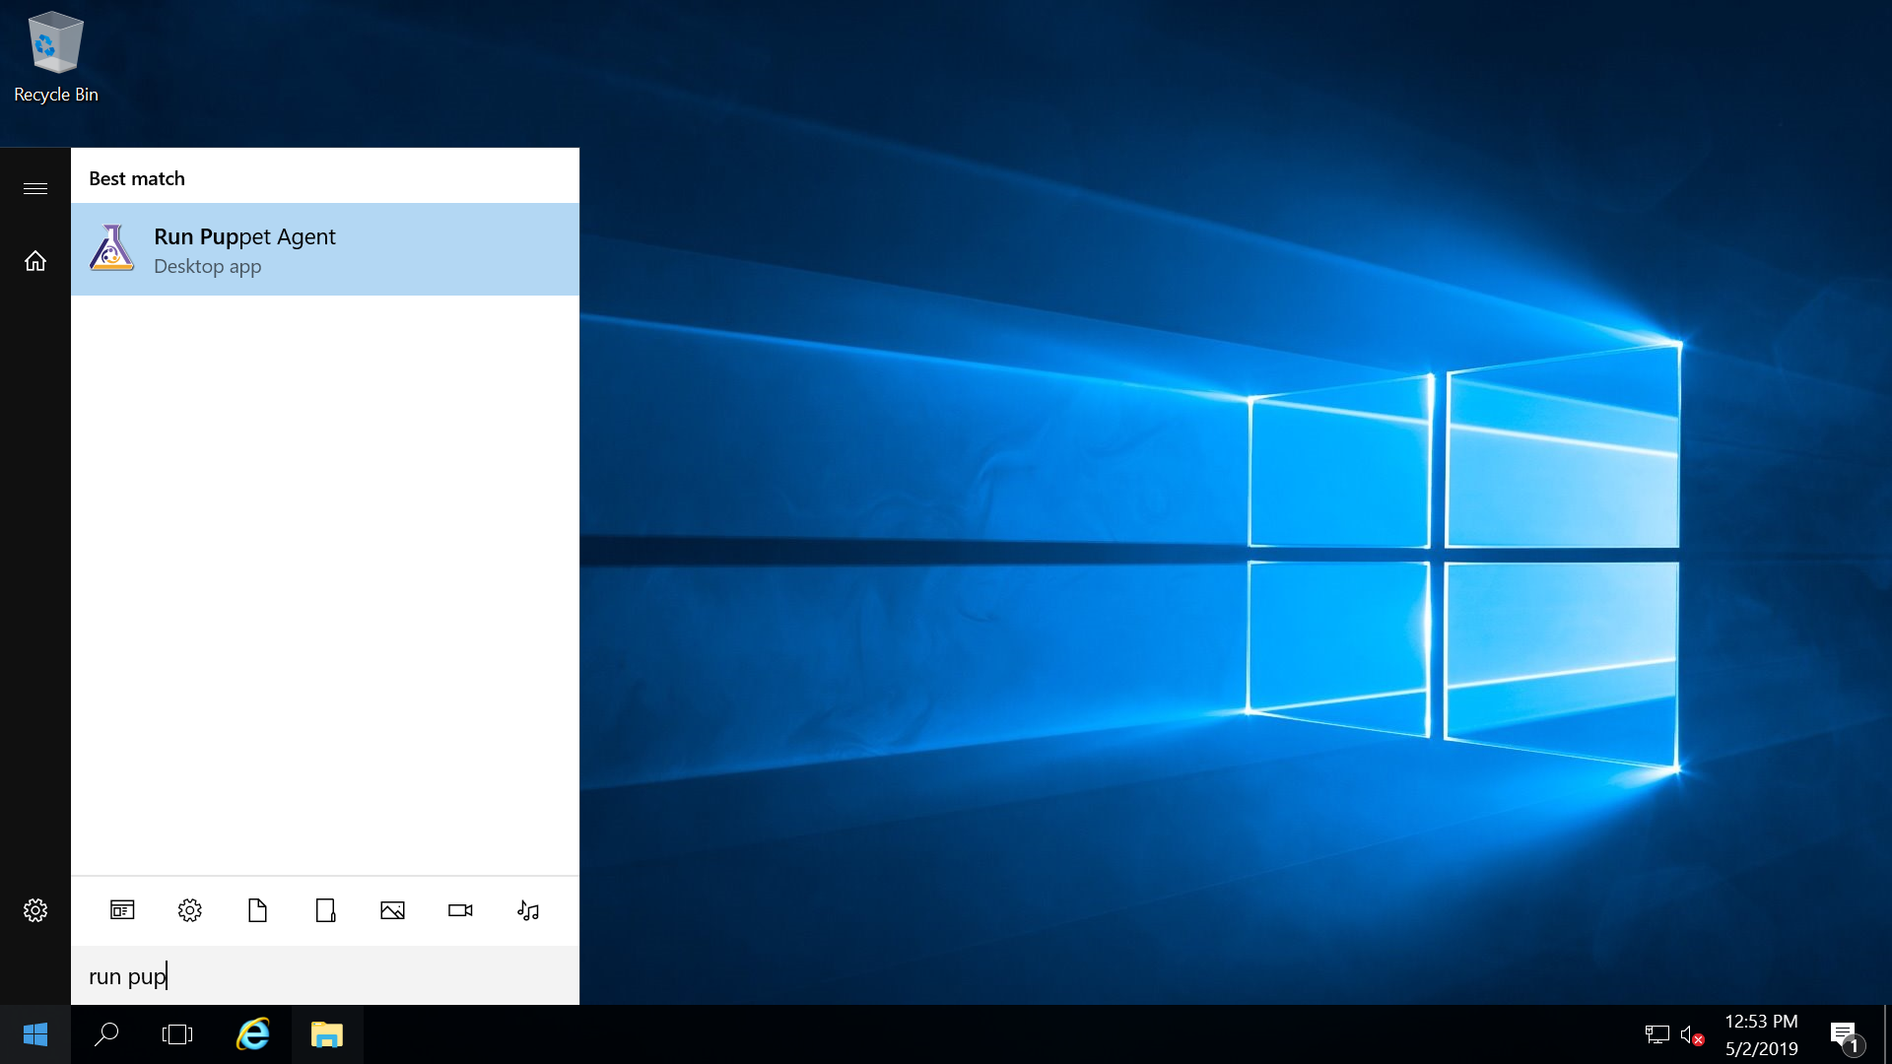

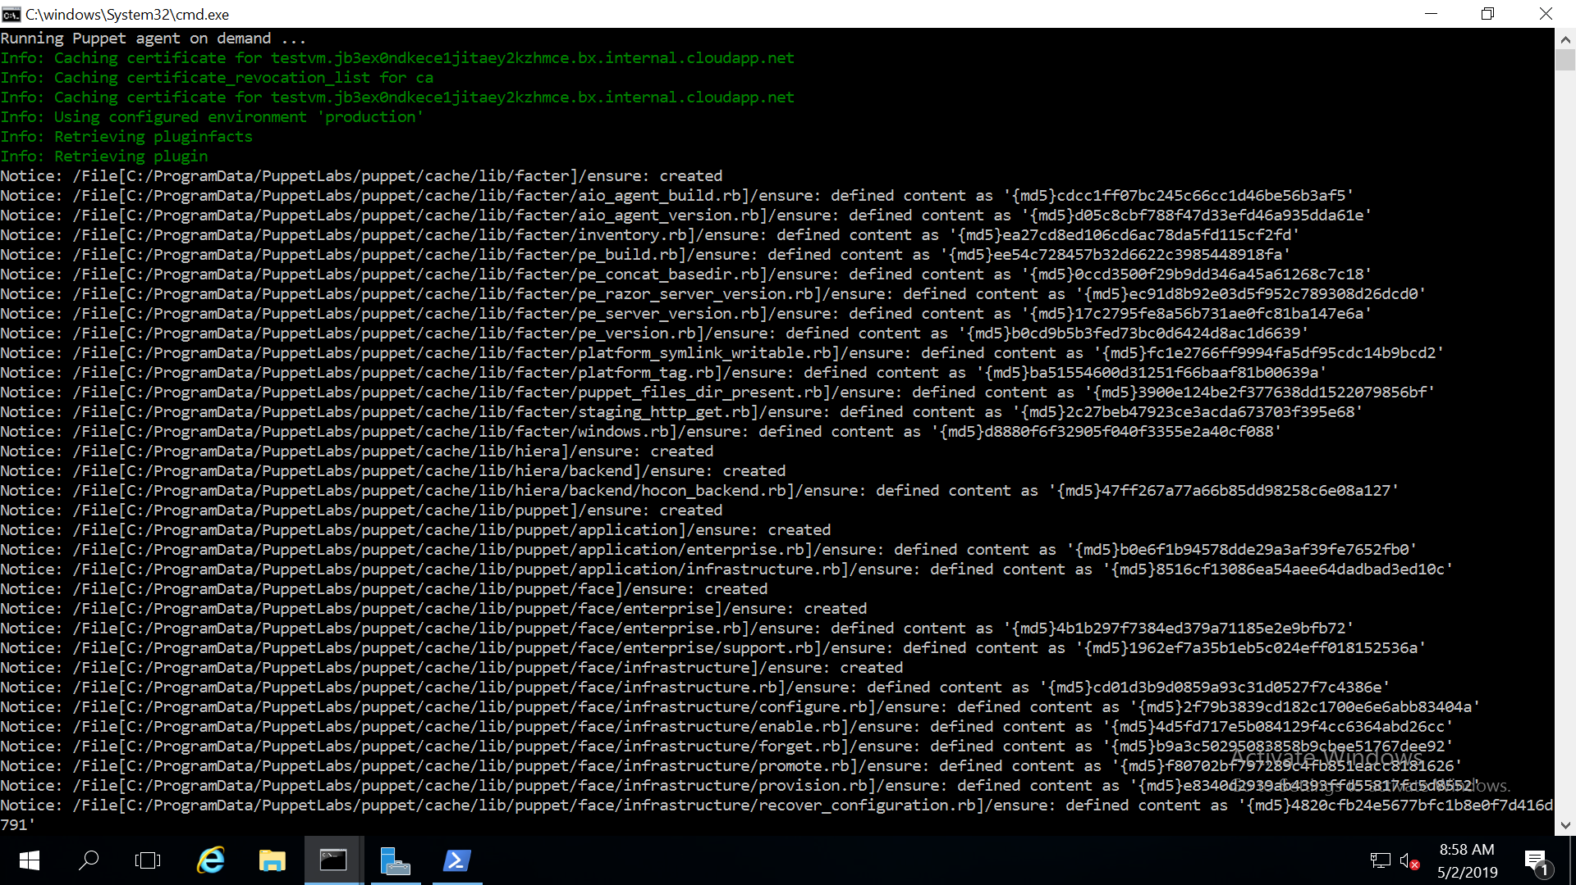

**Test Puppet**

Try the steps provided in the following link to copy a file using puppet

<https://medium.com/@vimukthiperera/how-to-write-a-simple-module-to-copy-a-file-using-puppet-5-4-0-on-ubuntu-18-04-b223270766b6>

**VM Image Capture**

Step1: Generalize the Client VM and create an image of the VM as per the following document

<https://docs.microsoft.com/en-us/azure/virtual-machines/windows/capture-image-resource>

Step2: Create a new VM using the image captured

**Test Puppet Connectivity**

Step1: Open the puppet console and accept the certificates

Go to Unsigned certs -> Accept



Step2: Connect to the VM and go to start and search for “Run Puppet Agent”



**Issues Faced**

Size Limitations



Create a Puppet VM with Minimum Capacity – 2VCore, 1 GB memory with DNS name configured

**Reference**

<https://www.tutorialspoint.com/puppet/puppet_overview.htm>

<https://docs.microsoft.com/en-us/azure/virtual-machines/windows/capture-image-resource>

<https://yourbusiness.azcentral.com/edit-files-ubuntu-via-putty-10037.html>

<https://puppet.com/docs/pe/2017.2/trouble_comms.html#is-the-puppet-master-reachable-from-the-agents>